Philomath Fire and Rescue Volunteer Association, Inc

Board Report
13 June 2022

Volunteer Recruitment and Retention

Recruitment activities took place at the Philomath Block Party. Three members staffed Old Engine 1 as part of the classic car section of the party. In addition to showing the engine, answering questions, and passing out badge stickers to children, five potential volunteers indicated their interest in joining the department. The Recruitment and Retention ad hoc committee met before the business meeting developing plans for future events and advertising along with an annual budget.

The recruitment for resident volunteers by other jurisdictions has become very competitive. Many organizations offer, in addition to college tuition, monthly stipends, meals while on shift, and fuel reimbursement. We are trying to identify and focus on candidates that would be attracted to our program rather than those with more generous incentives. An example would be an OSU student due to our proximity to campus.

Volunteer Status

We have included this section to describe the volunteer program more fully.

As of 10 June, current count of volunteers: 41
- RVs: 6 (one on light duty, one away at summer job, one working for ODF) effectively, 3 to 5. 3 new RVs coming in June (no experience).
  - The limited number of RV’s has led to an excessive workload put upon them and a decrease in staffing levels at St 201
- Volunteers that live in the district:
  - St 201-11 (one on light duty, one on limited duty).
  - St 202-2 (one medical standby only and one fire only-currently out of country).
  - St 203-3 (one on light duty for approximately 6 months).
- Volunteers that live outside of the district: 19.
- Volunteers by Rank:
  - Command
    - Assistant Chief: 1 (limited availability due to working in Prineville)
    - Captain: 1 (lives out of district, does one 12 hr shift per week).
    - Lieutenant: St 203 1
  - Crew Leader
    - Senior FF:1 ST 203
  - ENG: 4 St 201-2, St 202-1, St 203-1
  - FF: 25 (wide range of skills and experience)
  - EMS only: 8 (included in total above).
- EMS Certifications (all members, including paid staff)
    - EMR 7
    - Basic 24
    - Advanced 1
    - Intermediate 3
    - Paramedic 7
    - None 8

Active volunteers: 16 (6 RVs and 10 volunteers)
This number is subjective. It is based on observation of the activities of the Department. The count includes all RVs as they have regularly assigned shifts and community volunteers that respond to calls, participate in events and standbys, and log duty hours beyond the minimum requirement.

For clarification, RVs while assigned to 24-hour shifts are allowed to be gone for work and school without obtaining coverage. During those times the staffing at ST 201 dips below the desired 3 personnel and is generally filled in with response by 40-hour personnel, but at times they too are not available and the response from St 201 can be as little as 1 personnel. It should also be mentioned that many RVs are not at the station when not on duty.

There is a period after a new member joins the department that they have very limited ability to respond on calls due to limited qualifications and experience, generally about 6 months. The amount of time to bring new members up to speed differs from member to member depending on previous experience and certifications. The average length of service of an RV is about 18 months, volunteers that live in the district appears to be much longer, but it is unclear if that trend will continue.

The cost of a volunteer per year varies. We are unable to obtain accurate data as staff are forbidden to share the information with the Association. Chief Miller was quoted by the Philomath News that one RV costs a maximum of $10,800 per year. Other volunteers can be assumed to be less. A great deal of staff time is dedicated to initial and maintenance training of all volunteers. The spring newsletter states it cost $2,600 in initial training alone. It is essentially the lion’s share of the Deputy Chief’s workload and probably be included into the calculated cost along with college tuition, uniforms, PPE, approved/paid for training, vaccinations, and physicals ($600), housing (RV’s) and the Association activity budget.

Tactical Pause

The Association remains intent on the successful staffing of ST 202 in collaboration with Department leadership and the Union.

No meetings between Chief Miller and the Association have occurred since 8 Feb. The Association was instructed by the Chief to meet with the Deputy Chief to work on resolving the issue. All requests to meet have been rejected.

The Association and Union called for the Tactical Pause in early February due a staffing decision to place two RVs at ST 202 for a 24-hour shift each day. This staffing plan appears to be in response to a disputed reprimand of two RVs that were being housed in a construction office placed at ST 202 for housing due to overcrowding at St 201. The Volunteers were verbally reprimanded in front of their peers for not responding to calls when off duty. The Association represented them at their request and, amongst other issues identified, cited the RV job description stating RVs were only required to respond while off duty to MVAs and Fires. After a prolonged process the issue was settled and then followed almost immediately with the new staffing plan.

The Tactical Pause has three areas.

Safety- The number, training, experience, and qualifications of assigned personnel is not currently documented for staffed stations. Staffing Station 202 at most times leaves below safe staffing at Station 201 and Station 202 for fire calls. There is currently an insufficient pool of personnel to achieve safe staffing levels.

- We currently do not roster an adequate number of RVs to staff St 201 and 202. 15, 5 per shift would be required to staff consistently and sustainably. This would staff 2 RVs at St 201 and 202 with one RV to cover vacancies due to school, work, and illness. Considering the average length of service for an RV is 18 months, you would need to train 10 new RV’s a year with the knowledge that they will have minimal skills for at least 6 months.

- Chief Miller has stated the minimum staffing level and qualification would be an Emergency Medical Responder (EMR), the least amount of medical training recognized by the state (See scope of practice attached), and person that is a driver/operator (can drive our smaller vehicles like the rescue, not a fire engine/truck or tender). If the EMR is also a driver-operator, the second person requires no qualifications. No level of experience or other training is required.

It should be noted that EMR training includes only rudimentary training in taking command of a scene, and that the training, according to Captain Saalsaa, is meant for augmentation of EMS crews at a basic level where an EMT or above is in charge. They are specifically trained to begin the process of stabilization – they cannot perform interventions such as nebulizers, epinephrine injections, CPAP, apply 4 or 12 lead ECGs, or even take blood sugar samples. 75-80% of the EMS calls in the 202/Blodgett/Kings Valley area require ALS personnel according to the 2021 and 2022 statistics. The Association and Union have both strongly recommended that one EMT would be the minimum requirement.

Offers to develop the qualifications, training, and a task book to show proficiency have been rejected. One assigned personnel needs to have skills to command the first 10-20 minutes of any emergency they respond to, medical, fire, MVA, Hazmat, and other highly dangerous situations. The one-hour class given by Chief Ferguson does not meet this need.

- Chief Miller has pointed out that RVs are being housed at St 203 and it is not an issue. The Association agrees. We look at that arrangement differently than St 202. St 203 has active volunteers living in the area including a Lieutenant and Senior Firefighter that respond with the RVs, providing a crew with adequate supervision, training, and experience. The assigned RVs do not respond without the Community Volunteers. Further, the station is physically secure with the living space within the building which has adequate facilities including a kitchen and restroom.

Operating guidelines- No formal written operating policies /guidelines are available. The current Standard of Coverage does not fulfill this.

- Currently, we have no staffing guidelines for in district responses. We were made aware of this when the Ad Hoc Staffing committee requested paper copies of the current polices and were informed the requested items had been superseded by the 2021 Standard of Cover. Removed items were Section O, Response Guidelines, O-13 “Staffing for Response” and Section O, Minimum Staffing, Procedure O-21 “Minimum Staffing / Apparatus Level in District”. Chief Miller attended one of the meetings and stated the section in the 2021 Standard of Cover titled “Minimum Staffing, Apparatus Levels in District” (page 19) “does not apply to in district responses” as it is a “typo” further stating “it would back us into a corner”. The resulting lack of response guidelines was unknown to all personnel until that time.

Logistics- The personnel quarters at Station 202 needs improvements to provide for the privacy, safety, and comfort of assigned personnel.

- To our knowledge, no actions have been taken to address the logistical issues identified in the listening sessions regarding security, the sleeping quarters, bathrooms, and kitchen.

- The addition of the living quarters trailer and other station modifications were done without permits from Benton County. See attached permit history of ST202 and email from Capt. Louden regarding St 202 building projects advice.

Philomath News article.

We appreciate the thoughtful and broad article regarding St 202. While unfortunate that our internal strife is now in public view, we hope it helps lead the department to a positive outcome. We have expounded our position on some of the contents below.

- President Louden was quoted “We are not opposed to Staffing 202”; “We just want to make sure everybody’s trained properly because we don’t want to send kids out there and have them be overwhelmed. The public should get what they are expecting, and a kid should not be scarred for life because they didn’t know what to do or get themselves killed.”

This is the issue in a nutshell. Chief Miller’s email accusing us of “throwing up roadblocks” and opposing his actions as being “insubordination” is telling. We are not throwing up roadblocks, we are attempting to make the staffing St 202 successful for all involved. The planning of staffing St 202 did not include any input from volunteer officers or union officers. An email was sent by Chief Miller announcing the plan.

- Chief Miller is quoted as saying “…any response beyond 15 minutes is not an effective response”.

The Association believes this is generally true, but a response goes beyond the time it takes an apparatus to arrive--it includes the responding personnel’s ability to provide effective service in a safe manner. The proposed staffing plan does not assure this.
- No current RV is qualified to lead a fire attack of any kind, structure, vehicle, or wildland.
- Structure or wildland (there is no wildland engine at 202).
- Most RVs are not qualified to operate a fire engine in the first year of their service.
- New RVs are generally not qualified to enter a burning building as part of a crew for several months after hire.
- As stated earlier, EMR’s are not trained to lead a medical call. EMT and EMR are NOT synonymous.

Chief Miller is quoted regarding the length of RV service in the department: “It’s just long to get them through the fire academy, EMT school and then if we’re lucky, we get them to be able to drive a fire truck – and then they leave.”

We agree. While short in duration, RVs are an essential element of the department. They fill a vital role in our daily response staffing. Due to their short time here, their training is limited to being a basic firefighter and medical provider. To compensate for their lack of experience, RVs work under the direction of a Lieutenant that provides the required supervision of actions. We do not train them to be a crew leader, we train them to be part of a crew.

- Chief Miller is also quoted: “The max that we have to pay to them in a year is $10,800… so if you think about you get a person year -round for $10,800, it's way cheaper than trying to pay a full-time employee”.

We agree that RVs are an incredible value, but they are NOT equivalent to a full-time employee. The Association has agreed that RV’s that are supervised by an officer or Senior Firefighter can be used in any circumstances, including ST 202.

Chief Miller announced that the department has received a grant from the Oregon State Fire Marshal for $32,500 for staffing this summer to bolster our wildland fire response. Over 100 Oregon departments are expected to receive this grant. These funds will go towards two part time employees to cover 202 during weekdays. We have limited them to 30 hours a week due to the cost of insurance. The Funds must be expended and accounted for by 15 November. We are hopeful those hired possess the skills to lead a crew effectively. Merely employing an RV as a part time employee does not resolve the training, qualification, and experience issue.

Respectfully submitted.

Andrew Louden Jessica Olsen
President Vice President

Jean Goul Samantha Schmeusser
Treasurer Secretary (Acting)

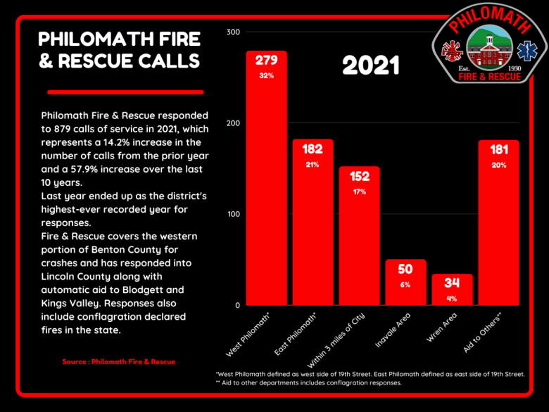

Statistical information for the 202 Response Area that includes KVAL and BLOD

2021:
Total calls: 90
In district: 34
Out of district: 56
Fire calls: 24
Medical, code 1 (BLS) calls: 11
Medical, code 3 (ALS) calls: 55

Spring 2022 Newsletter
“We also set a record of the number of back- to-back calls which happened on 51 occasions in 2021. These are calls that we are paged out before the first unit has returned to quarters. This has required us to change our response matrix to ensure coverage of the Fire District. We can no longer afford to send all members of the response crew to every call. Instead, we are now keeping two personnel back in quarters, to be ready for when a second call arises.
A new addition to our response model is having two-personnel crew at Station 202 in Wren. Due to the lack of volunteers in the area and increased demand for calls to the Wren, Blodgett, and Kings Valley areas, we are staffing Station 202 in Wren in order to maintain staffing in Station 201 in Downtown Philomath. We are very excited about this change because stationing personnel in Wren will shaved off 7 minutes of response time to West Benton County, which means we can get an AED to a cardiac patient or start flowing water on a fire that much quicker.”

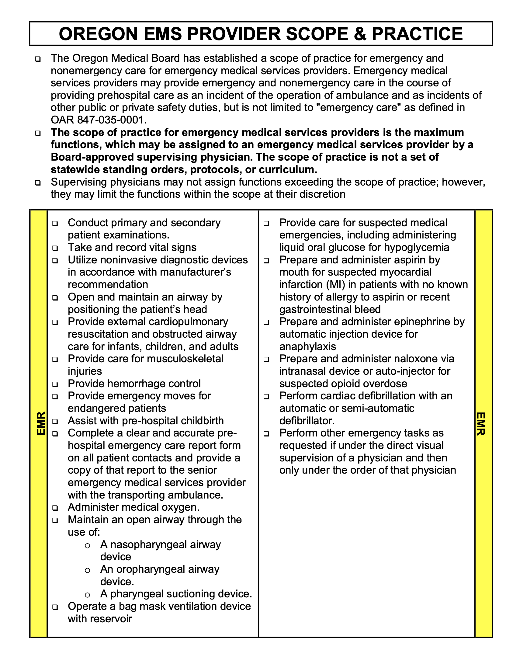

St 202 Project
You forwarded this message on Thu 4/7/2022 9:45 AM
AL
Andy Louden
To:
- Tom Miller
Cc:
- Chancy Ferguson
Wed 4/6/2022 11:45 AM
Chief
Thanks for the conversation on St 202 at the Association business meeting. I want to pass on some information from my experience at CFD managing the facilities and my personal business of renovating homes.
- Early contact with both the Development and Planning offices of the JHA, in this case, Benton County. In about an hour of conversation you can get a rough idea of what you can and cannot do and what codes apply. As I mentioned last night, fire stations come under category 4 seismic requirements and any structure, including a pole building, must be engineered to that level. The same is true for the remodel of current structure if the county determines due to the change in occupancy (S to R3) the remodel would not be considered an existing non-conforming and therefore come under the category 4 requirements. In any case, the remodel of the existing building will come under current residential code including the energy code.
- Contact the county sanitarian regarding the septic system capacity as we are going to a continuously occupied status at the facility. There also may be an issue regarding the drain field if it is not fully contained on the 1-acre parcel.
- The project will likely come under Oregon prevailing wage laws and could greatly increase the cost of the station. Building materials of all types are experiencing hyperinflation and shortages. Same is true for the cost of labor.
- I would highly recommend a station location study. A local company does this work nationwide and has offered to do a study for us for about $1000, a bargain when you consider the life of the station could exceed 50 years. Putting the station in the right place now is way cheaper than moving it in the future.
- I would highly recommend that you hire a project manager/consultant to help develop a feasibility study and cost estimate. In my experience, these projects are more complicated and expensive than one would assume. Knowing this up front will allow you to make a good plan that you can afford and a realistic timeline (and avoid a bunch of grief in the future).
I hope this email is helpful. I have the names of folks that have helped me through complex projects like this in my career. I'd be happy to pass them on to you if you wish.

Andy

